**Hive to Hbase connection example :**

**Hbase command:**

hbase(main):019:0> create 'student_marks','personal_details','exams_info'

**Hive command:**

CREATE EXTERNAL TABLE IF not exists hbase_student_marks

(key string,

gender string,

group string,

parental_level_of_education string,

lunch string,

test_preparation_course string,

math_score int,

reading_score int,

writing_score int

)

ROW FORMAT DELIMITED

FIELDS TERMINATED BY ','

STORED BY 'org.apache.hadoop.hive.hbase.HBaseStorageHandler'

WITH SERDEPROPERTIES

("hbase.columns.mapping"=":key,personal_details:gender,personal_details:group,personal_details:parental_level_of_education,personal_details:lunch,exams_info:test_preparation_course,exams_info:math_score,exams_info:reading_score,exams_info:writing_score")

TBLPROPERTIES("hbase.table.name"="student_marks")

;

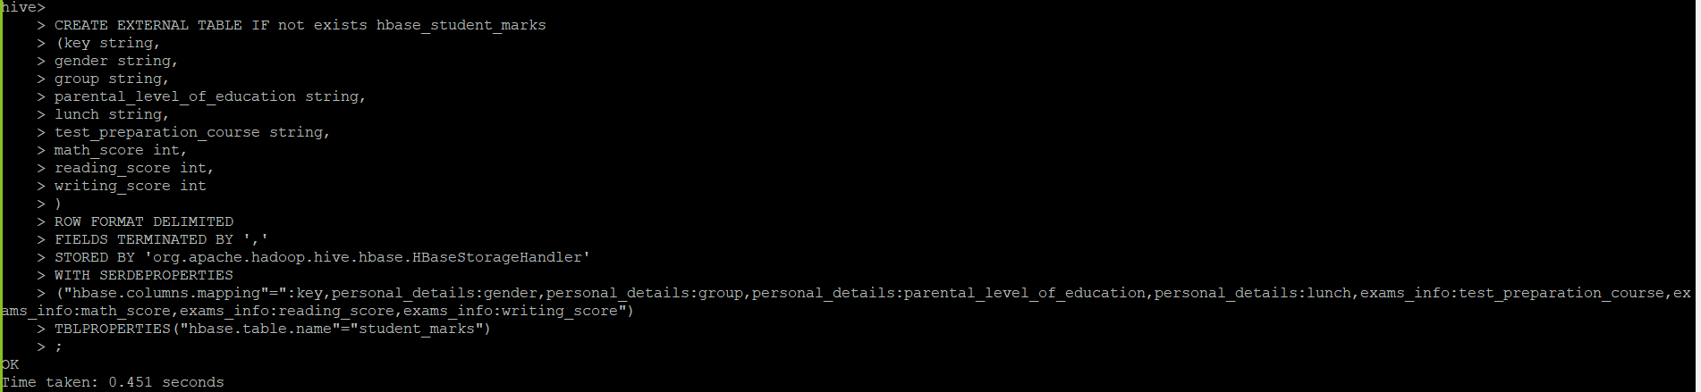

CREATE EXTERNAL TABLE IF not exists stg_hbase_student_marks

(key string,

gender string,

group string,

parental_level_of_education string,

lunch string,

test_preparation_course string,

math_score int,

reading_score int,

writing_score int

)

ROW FORMAT DELIMITED

FIELDS TERMINATED BY ','

TBLPROPERTIES("skip.header.line.count"="1")

;

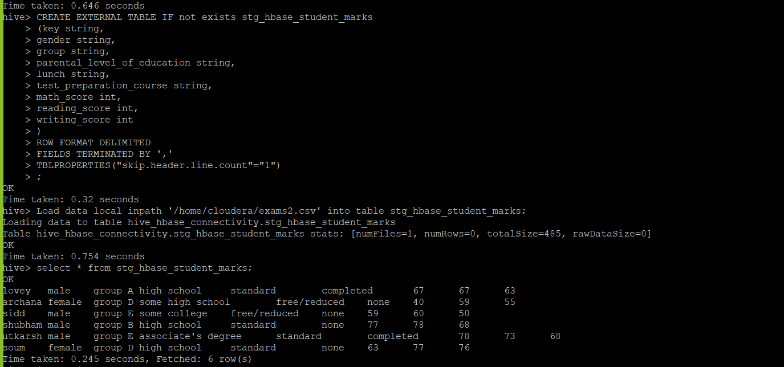

**Loading the data into a stage table.**

hive> Load data local inpath '/home/cloudera/exams2.csv' into table stg_hbase_student_marks;

**Insert the data from stage table to main hive table**

hive> insert into table hbase_student_marks select * from stg_hbase_student_marks;

hive> select * from hbase_student_marks;

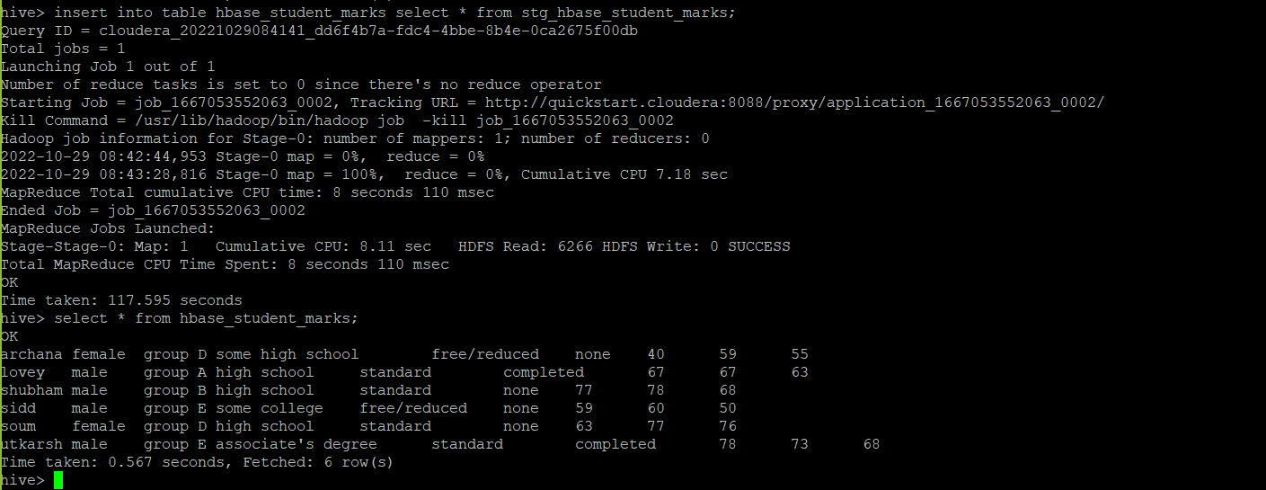

hbase(main):019:0> scan 'student_marks'

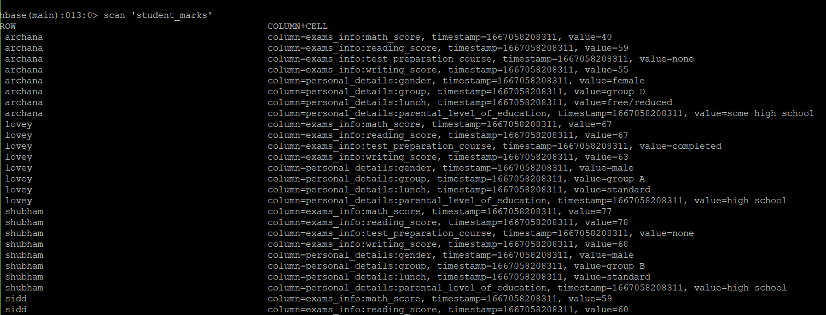

hbase(main):019:0> count 'student_marks'

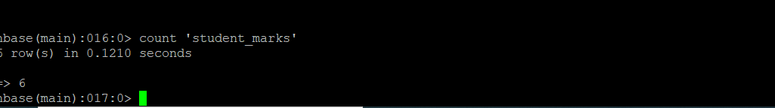

hbase(main):019:0> get 'student_marks','lovey','personal_details'

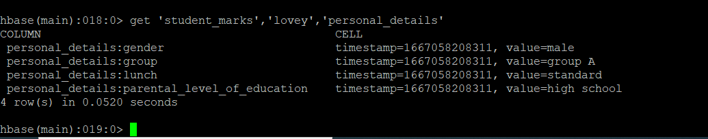

hbase(main):019:0> put 'student_marks','siddhesh','personal_details:gender','Male'

hbase(main):019:0> get 'student_marks','siddhesh','personal_details:gender'

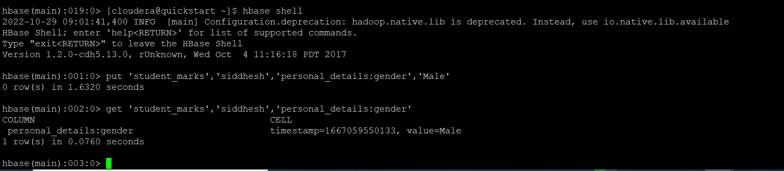

Hive> select * from hbase_student_marks where key ='siddhesh' ;

